BEACONHOUSE NATIONAL UNIVERSITY
School of Computing & Information Technology
LAB ASSIGNMENT 1
Hybrid Network Topology Design
Using Cisco Packet Tracer

Course | Computer Networks Lab (Lab-209)
Semester | Spring 2026
Institution | Beaconhouse National University
Instructor | Shazia Rizwan
Lab Instructor | Hasnain Ahmad
Total Marks | 20 Marks
CLOs Covered | CLO 4 (Apply - C3)
Submission | Submit .pkt file + screenshots via LMS

Student Name: Saad Mughal Roll No: F2023-009 Section: C

1. Learning Objectives
By completing this assignment, you will be able to:
- Understand what a Hybrid Topology is and why it is used in real networks
- Build a multi-segment hybrid network in Cisco Packet Tracer
- Manually assign static IP addresses to devices across different segments
- Connect segments through a central router acting as a backbone
- Verify end-to-end connectivity between all devices using the ping command

Mapped CLO: CLO 4 — Configure network services in Cisco Packet Tracer [Apply — Bloom's C3]

2. Background — What is a Hybrid Topology?
A Hybrid Topology is a network design that combines two or more different topology types into a single unified network. Rather than using one topology for the entire network, engineers mix topologies to get the best characteristics from each.

In this assignment you will build a hybrid of two topologies:

Topology | How It Works | Role in This Assignment
Star Topology | All devices in a segment connect to a central switch. Easy to manage; one device failure does not affect others. | Each department segment uses a star topology with a local switch at the centre.
Bus (Backbone) via Router | All segments are connected through a single central router, creating a shared logical backbone. | Router0 acts as the backbone, linking all star segments so any device can reach any other.

3. Network Design
You will build a small campus network with three segments (IT, Admin, and Library), each connected to a central router. All devices will have manually assigned static IP addresses. No services like DHCP or DNS are required — just connectivity.

Network Overview

Segment | Devices | IP Range | Gateway (Router Interface)
IT Dept (Segment A) | Switch-A + 2 PCs | 192.168.10.0 /24 | 192.168.10.1
Admin Dept (Segment B) | Switch-B + 2 PCs | 192.168.20.0 /24 | 192.168.20.1
Library (Segment C) | Switch-C + 2 PCs | 192.168.30.0 /24 | 192.168.30.1

💡 Tip Router0 needs three interfaces — one per segment. Each interface IP becomes the gateway for that segment's PCs.

3.1 Static IP Address Plan
Assign the following static IPs to every device in your topology:

Device | Segment | IP Address | Subnet Mask / Gateway
PC-A1 | IT (Seg A) | 192.168.10.10 | 255.255.255.0 / GW: 192.168.10.1
PC-A2 | IT (Seg A) | 192.168.10.11 | 255.255.255.0 / GW: 192.168.10.1
PC-B1 | Admin (Seg B) | 192.168.20.10 | 255.255.255.0 / GW: 192.168.20.1
PC-B2 | Admin (Seg B) | 192.168.20.11 | 255.255.255.0 / GW: 192.168.20.1
PC-C1 | Library (Seg C) | 192.168.30.10 | 255.255.255.0 / GW: 192.168.30.1
PC-C2 | Library (Seg C) | 192.168.30.11 | 255.255.255.0 / GW: 192.168.30.1
Router0 Gi0/0 | IT (Seg A) | 192.168.10.1 | 255.255.255.0 / —
Router0 Gi0/1 | Admin (Seg B) | 192.168.20.1 | 255.255.255.0 / —
Router0 Gi0/2 | Library (Seg C) | 192.168.30.1 | 255.255.255.0 / —

4. Step-by-Step Instructions
Follow each step in order. Boxes marked 🔧 Try It Yourself encourage you to attempt the step on your own before reading the hint.

Step 1 — Create a New Project

- Open Cisco Packet Tracer and log in with your NetAcad account.
- Go to File → New to open a blank workspace.
- Immediately save the file: File → Save As → YourName_RollNo_HybridTopology.pkt

💡 Tip Press Ctrl+S frequently throughout this assignment to avoid losing your work.

Step 2 — Place All Devices

From the Device Panel at the bottom of the screen, drag the following devices onto the workspace:

Device Type | Model | Qty | How to Find It
Router | 2911 | 1 | Routers category → 2911
Switch | 2960-24TT | 3 | Switches category → 2960-24TT
PC | Generic PC | 6 | End Devices category → PC

- After placing devices, rename each one by double-clicking its label under the icon. Use the names from the IP plan: PC-A1, PC-A2, PC-B1, PC-B2, PC-C1, PC-C2, Switch-A, Switch-B, Switch-C, Router0.
- Arrange the layout with Router0 in the centre, and the three star segments (A, B, C) spread around it — this makes the hybrid structure visually clear.

🔧 Try It Yourself Before wiring anything, take a screenshot of your device layout. Does it clearly show the hybrid structure? A well-labelled topology diagram is part of your submission.
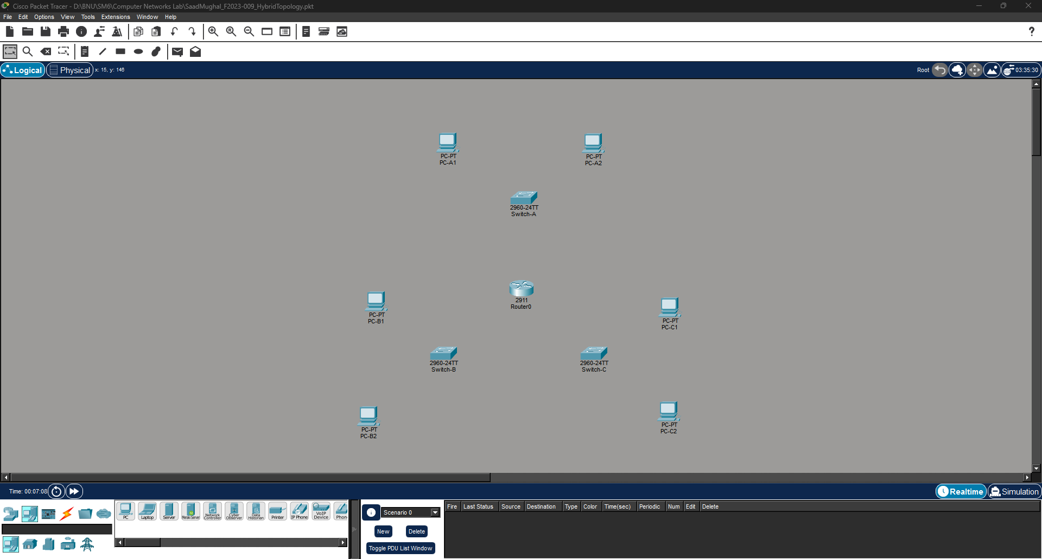

Step 3 — Connect All Devices with Cables

In the Connections panel (lightning bolt icon), select Copper Straight-Through cable for all connections in this assignment.

Connect From | Connect To | Cable Type
PC-A1 (FastEthernet0) | Switch-A (any FastEthernet port) | Straight-Through
PC-A2 (FastEthernet0) | Switch-A (any FastEthernet port) | Straight-Through
PC-B1 (FastEthernet0) | Switch-B (any FastEthernet port) | Straight-Through
PC-B2 (FastEthernet0) | Switch-B (any FastEthernet port) | Straight-Through
PC-C1 (FastEthernet0) | Switch-C (any FastEthernet port) | Straight-Through
PC-C2 (FastEthernet0) | Switch-C (any FastEthernet port) | Straight-Through
Switch-A (GigabitEthernet0/1) | Router0 (GigabitEthernet0/0) | Straight-Through
Switch-B (GigabitEthernet0/1) | Router0 (GigabitEthernet0/1) | Straight-Through
Switch-C (GigabitEthernet0/1) | Router0 (GigabitEthernet0/2) | Straight-Through

✅ Expected Result All link indicator dots should turn green within a few seconds of connecting. An orange or red dot means the wrong port was selected or the cable type is incorrect.

⚠️ Note When clicking to connect a cable, Packet Tracer will ask which port to use. Always select the FastEthernet or GigabitEthernet port — never the Console or USB port.

Step 4 — Configure Router Interfaces

The router must have each of its three interfaces activated and assigned an IP address. These IPs will serve as the default gateway for each segment's PCs.

- Click on Router0 to open its device window.
- Click the CLI tab.
- Press Enter if you see a prompt asking to continue. Then type the commands below exactly as shown:

! Enter privileged mode and global config
Router> enable
Router# configure terminal

! --- Configure interface toward Segment A (IT Dept) ---
Router(config)# interface GigabitEthernet0/0
Router(config-if)# ip address 192.168.10.1 255.255.255.0
Router(config-if)# no shutdown
Router(config-if)# exit

! --- Configure interface toward Segment B (Admin Dept) ---
Router(config)# interface GigabitEthernet0/1
Router(config-if)# ip address 192.168.20.1 255.255.255.0
Router(config-if)# no shutdown
Router(config-if)# exit

! --- Configure interface toward Segment C (Library) ---
Router(config)# interface GigabitEthernet0/2
Router(config-if)# ip address 192.168.30.1 255.255.255.0
Router(config-if)# no shutdown
Router(config-if)# end

! Save the configuration
Router# write memory

✅ Expected Result After typing 'no shutdown' for each interface, the router should print: %LINK-5-CHANGED: Interface GigabitEthernet0/x, changed state to up. This confirms the interface is active.

🔧 Try It Yourself After finishing, type 'show ip interface brief' in the CLI. You should see all three GigabitEthernet interfaces listed as 'up/up' with their assigned IPs. Can you find this output? Take a screenshot.
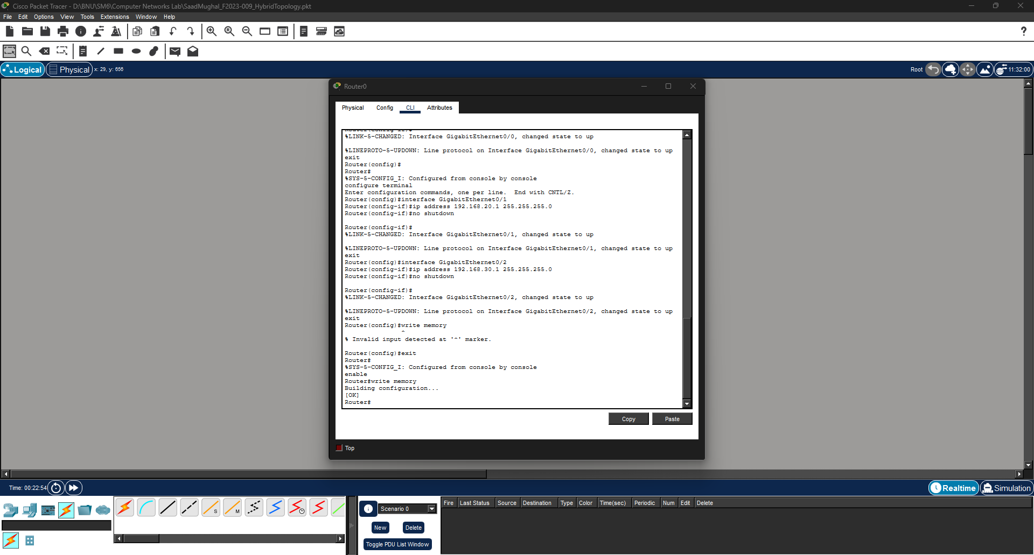
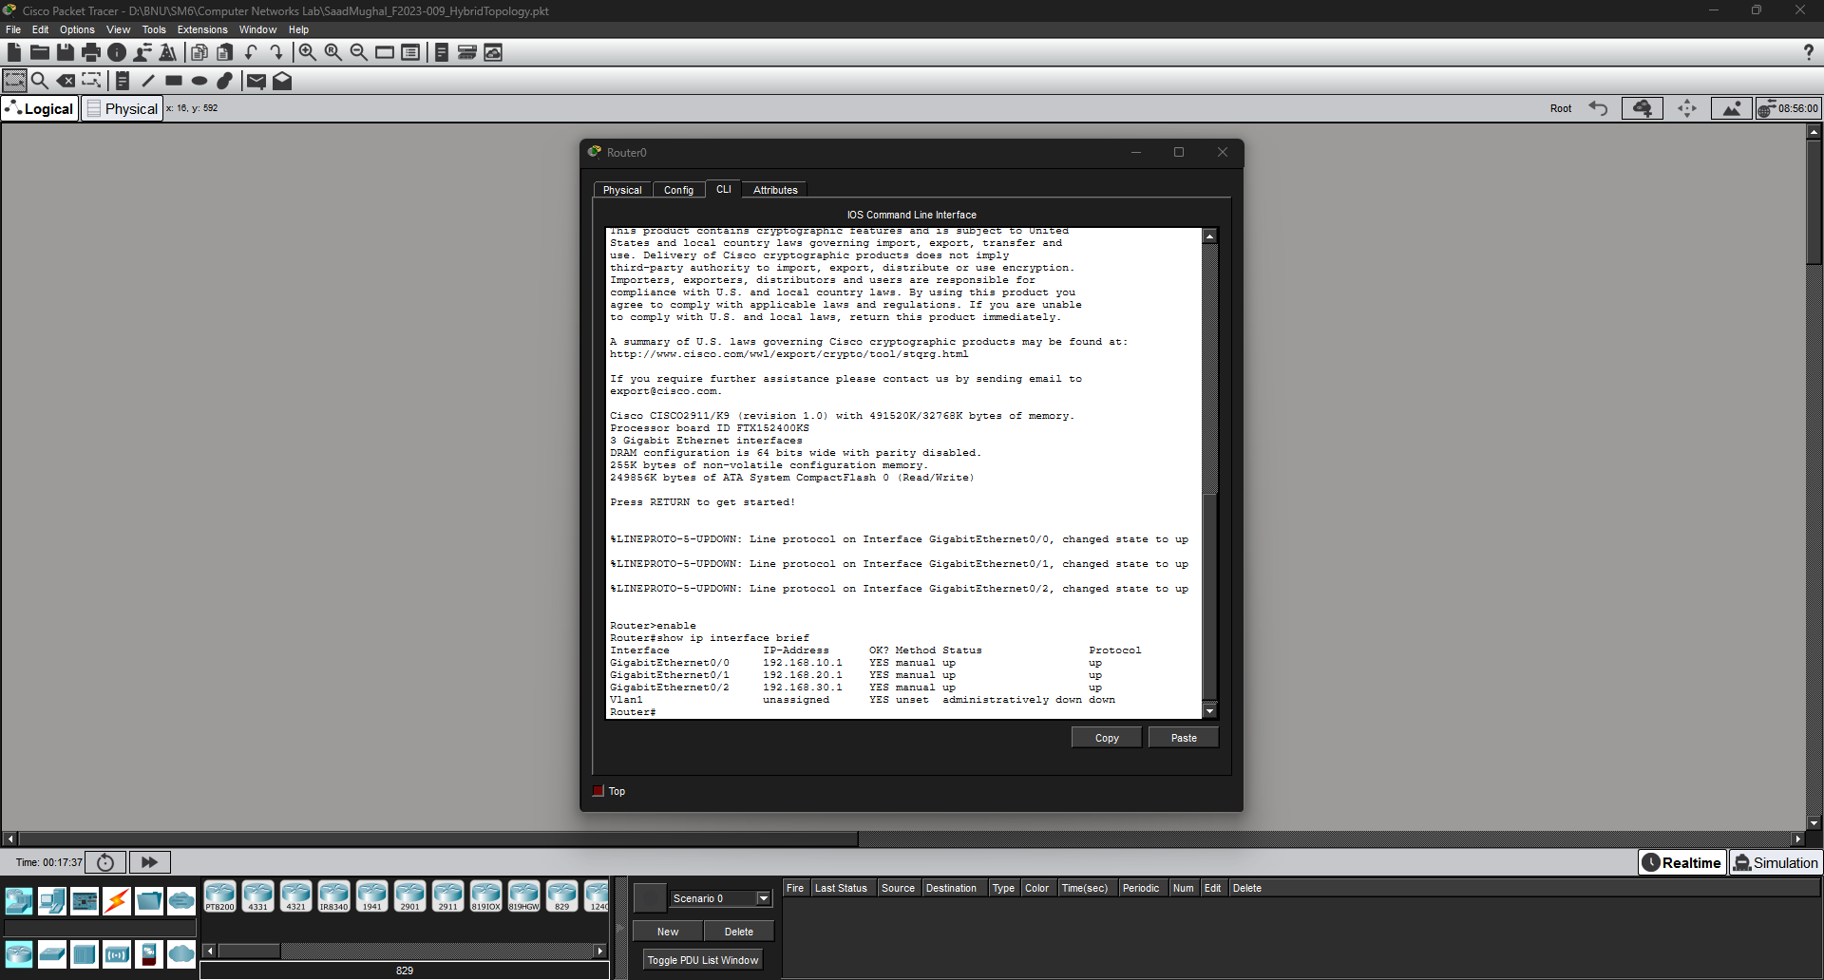

Step 5 — Assign Static IP Addresses to PCs

Every PC needs a static IP address, subnet mask, and default gateway. Repeat the steps below for each of the 6 PCs using the IP plan from Section 3.

- Click on a PC (e.g., PC-A1) to open its window.
- Go to the Desktop tab.
- Click IP Configuration.
- Select the Static radio button.
- Enter the IP Address, Subnet Mask, and Default Gateway from the IP plan table.
- Close the window. Repeat for all remaining PCs.

💡 Tip Work segment by segment — configure PC-A1 and PC-A2 first, then PC-B1 and PC-B2, then PC-C1 and PC-C2. This keeps things organised and reduces mistakes.

PC | IP Address | Subnet Mask | Default Gateway
PC-A1 | 192.168.10.10 | 255.255.255.0 | 192.168.10.1
PC-A2 | 192.168.10.11 | 255.255.255.0 | 192.168.10.1
PC-B1 | 192.168.20.10 | 255.255.255.0 | 192.168.20.1
PC-B2 | 192.168.20.11 | 255.255.255.0 | 192.168.20.1
PC-C1 | 192.168.30.10 | 255.255.255.0 | 192.168.30.1
PC-C2 | 192.168.30.11 | 255.255.255.0 | 192.168.30.1

🔧 Try It Yourself After configuring all PCs, pick any two in the same segment and try to ping one from the other (Desktop → Command Prompt → ping <IP>). Does it work? It should, because they share the same subnet and switch.

PC-A1:
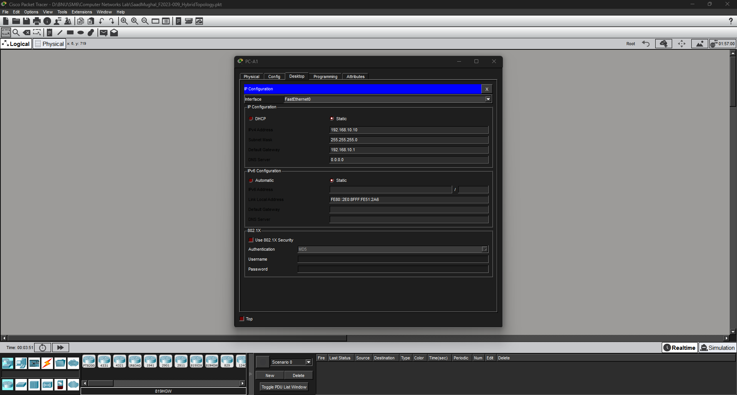

PC-A2:
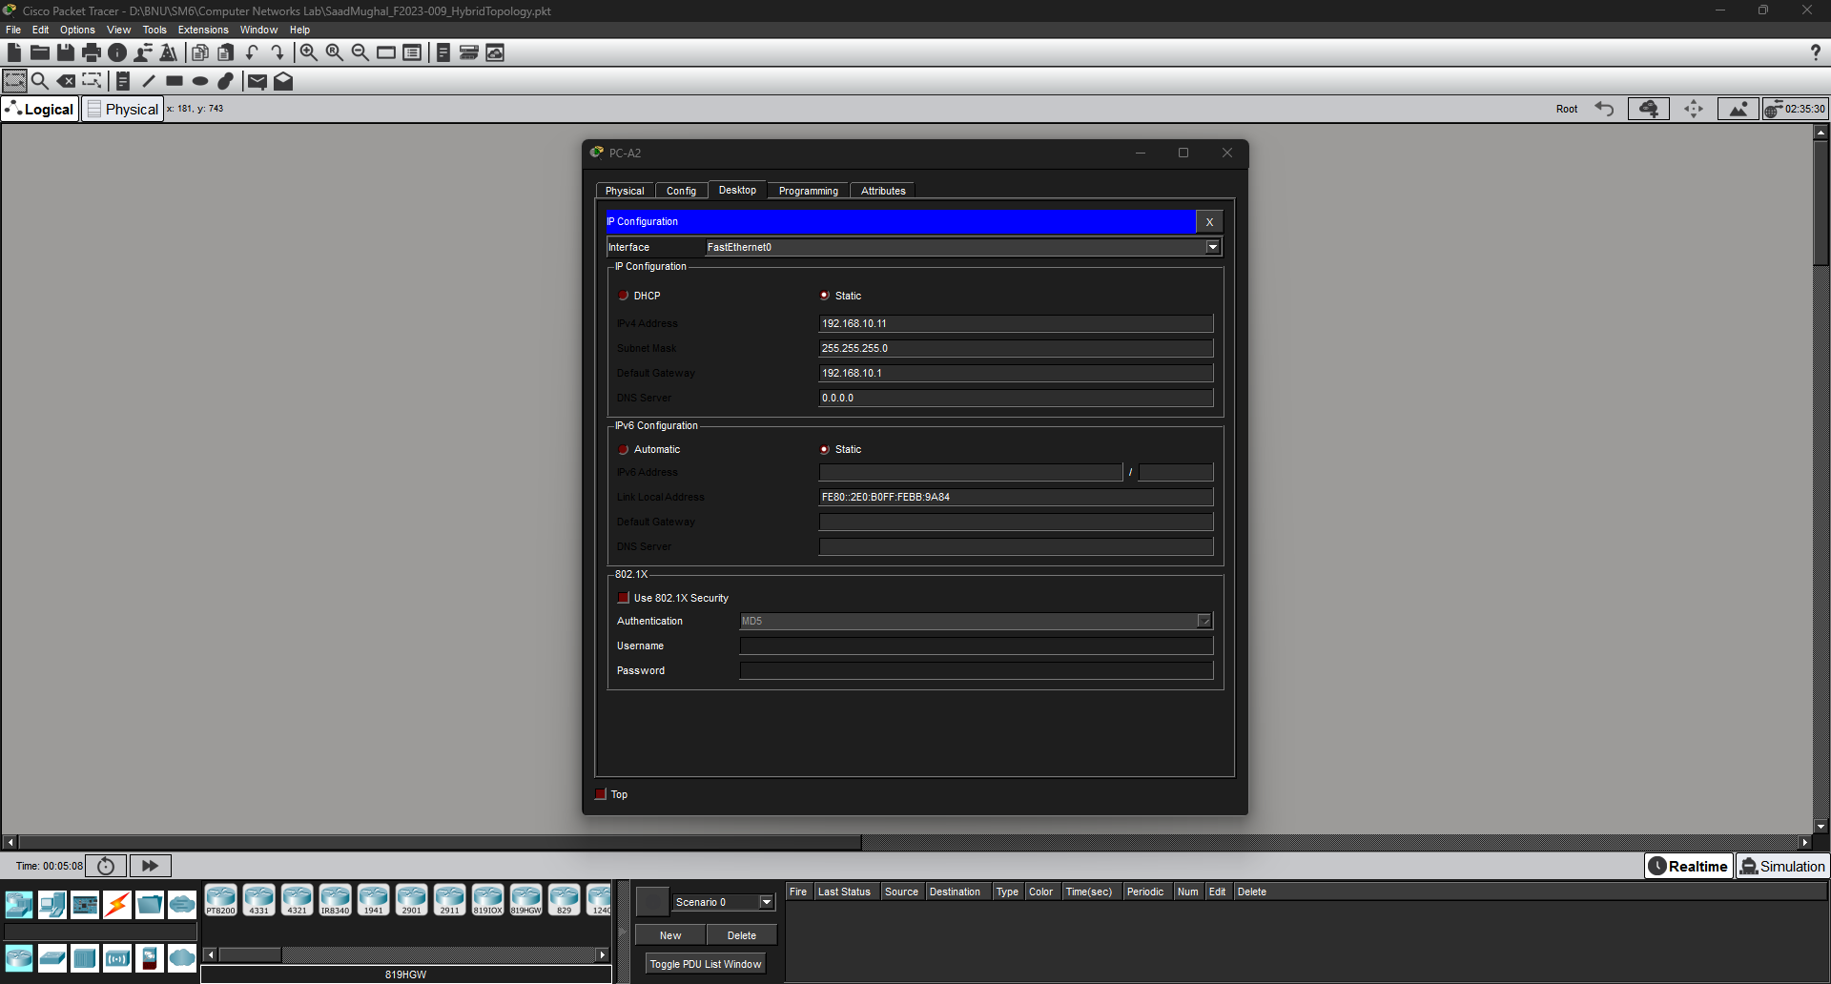

PC-B1:
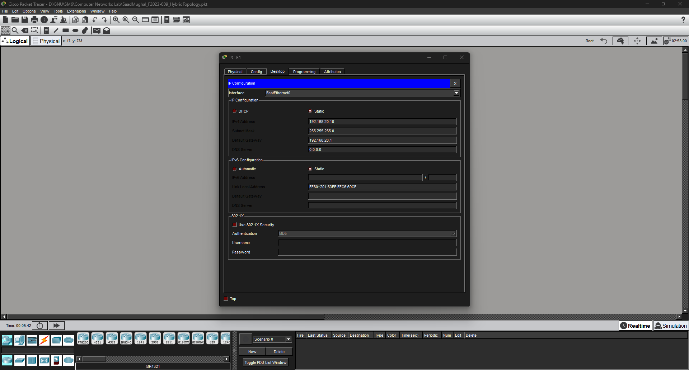

PC-B2:
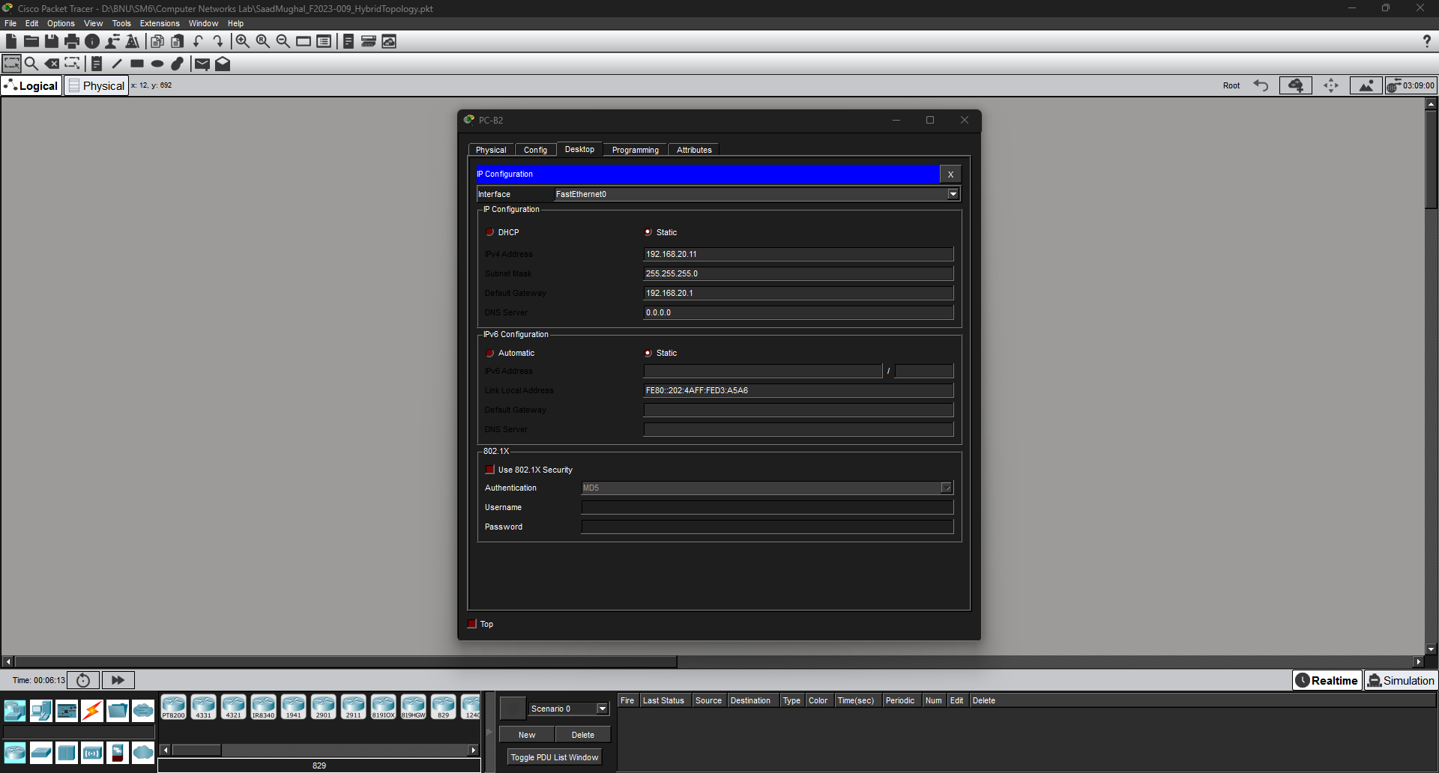

PC-C1:
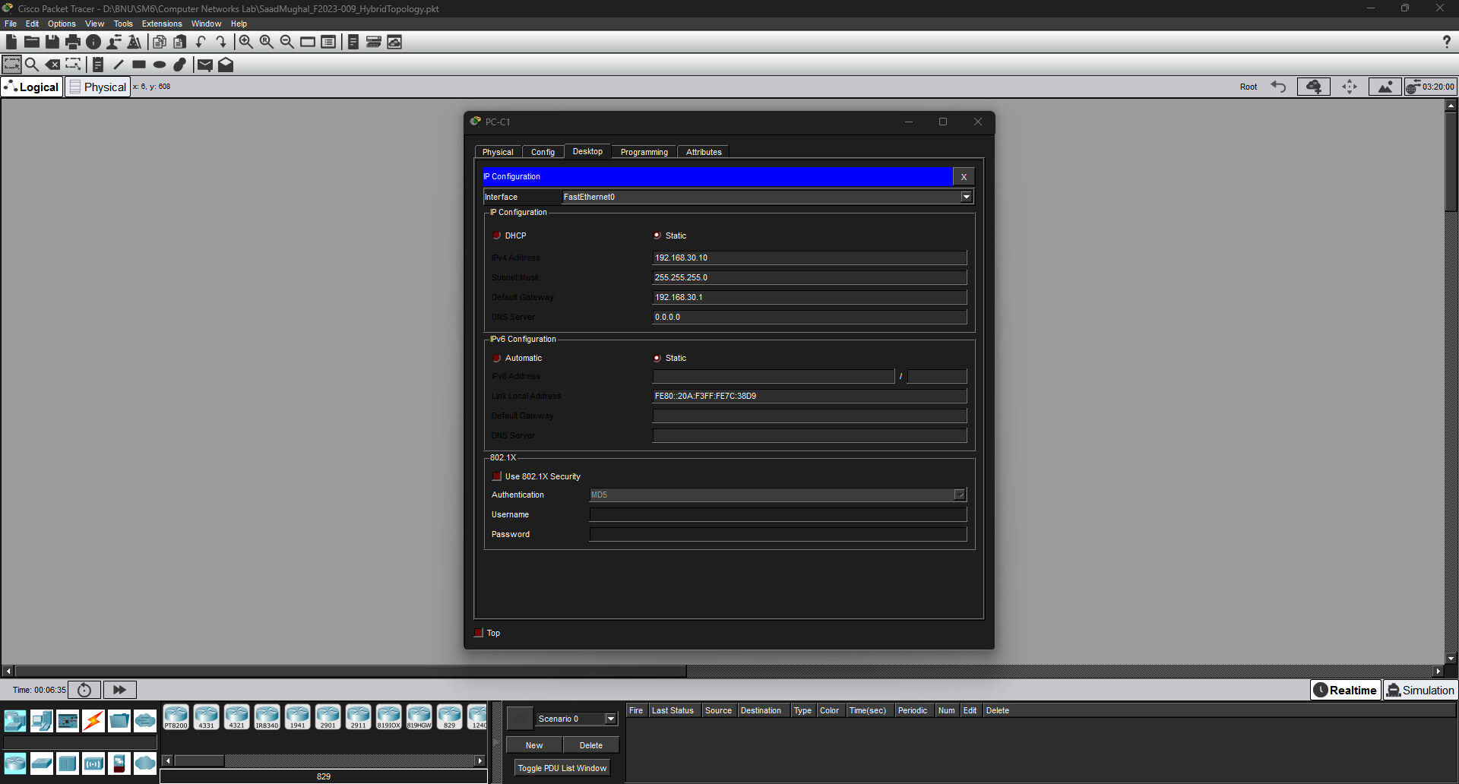

PC-C2:
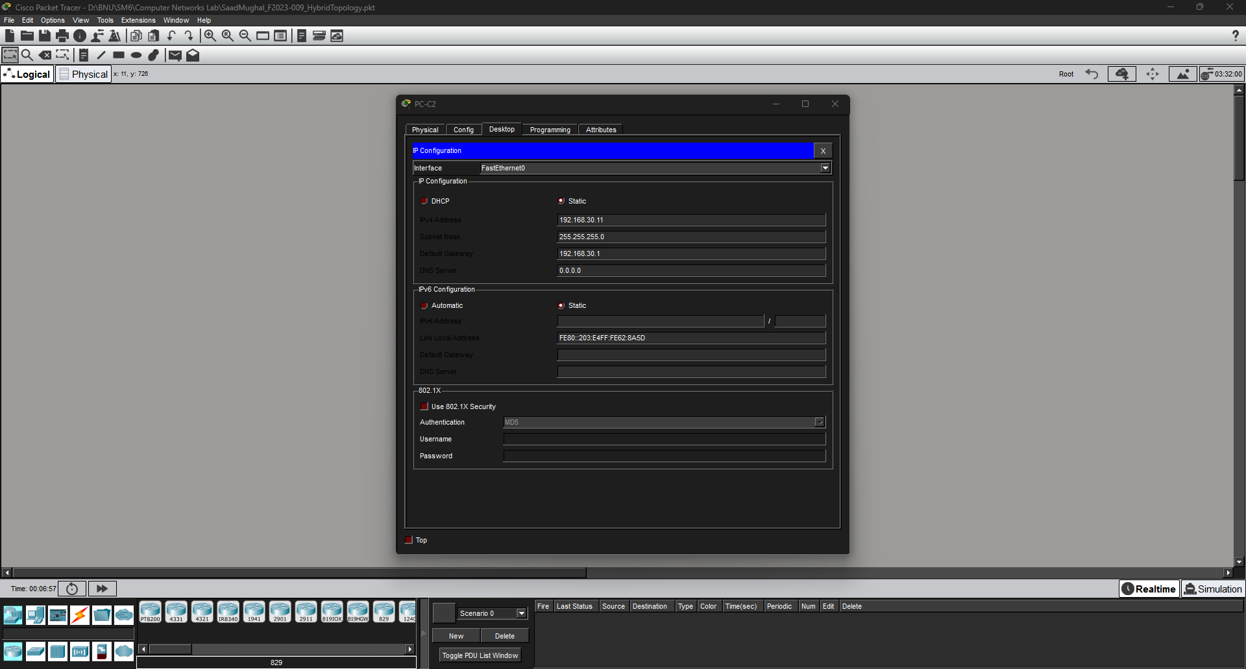

Step 6 — Verify Connectivity with Ping

Now that all IPs and the router are configured, test that every device can reach every other device across the entire hybrid topology.

How to run a ping in Packet Tracer
- Click on a PC.
- Go to Desktop → Command Prompt.
- Type: ping <target IP address> and press Enter.
- A successful ping shows four lines of: Reply from <IP>: bytes=32 time=<x>ms TTL=<n>

Test # | From | Ping Target | What This Verifies
1 | PC-A1 | PC-A2 (192.168.10.11) | Same-segment (Star) connectivity — Seg A
2 | PC-B1 | PC-B2 (192.168.20.11) | Same-segment (Star) connectivity — Seg B
3 | PC-C1 | PC-C2 (192.168.30.11) | Same-segment (Star) connectivity — Seg C
4 | PC-A1 | PC-B1 (192.168.20.10) | Cross-segment via Router — Seg A to Seg B
5 | PC-A1 | PC-C1 (192.168.30.10) | Cross-segment via Router — Seg A to Seg C
6 | PC-B2 | PC-C2 (192.168.30.11) | Cross-segment via Router — Seg B to Seg C

✅ Expected Result All 6 ping tests should succeed with 0% packet loss. Tests 1–3 confirm the star segments work. Tests 4–6 confirm the router backbone (bus) connects everything — proving the hybrid topology is fully functional.

⚠️ Note If a cross-segment ping fails (Tests 4–6): check that the router interface is up ('show ip interface brief'), and that the PC's Default Gateway matches the router interface IP for its segment.

🔧 Try It Yourself After completing all tests, try the tracert command on PC-A1: type 'tracert 192.168.30.11' and press Enter. How many hops are there? What does each hop represent in the topology?

FROM PC-A1 TO PC-A2:
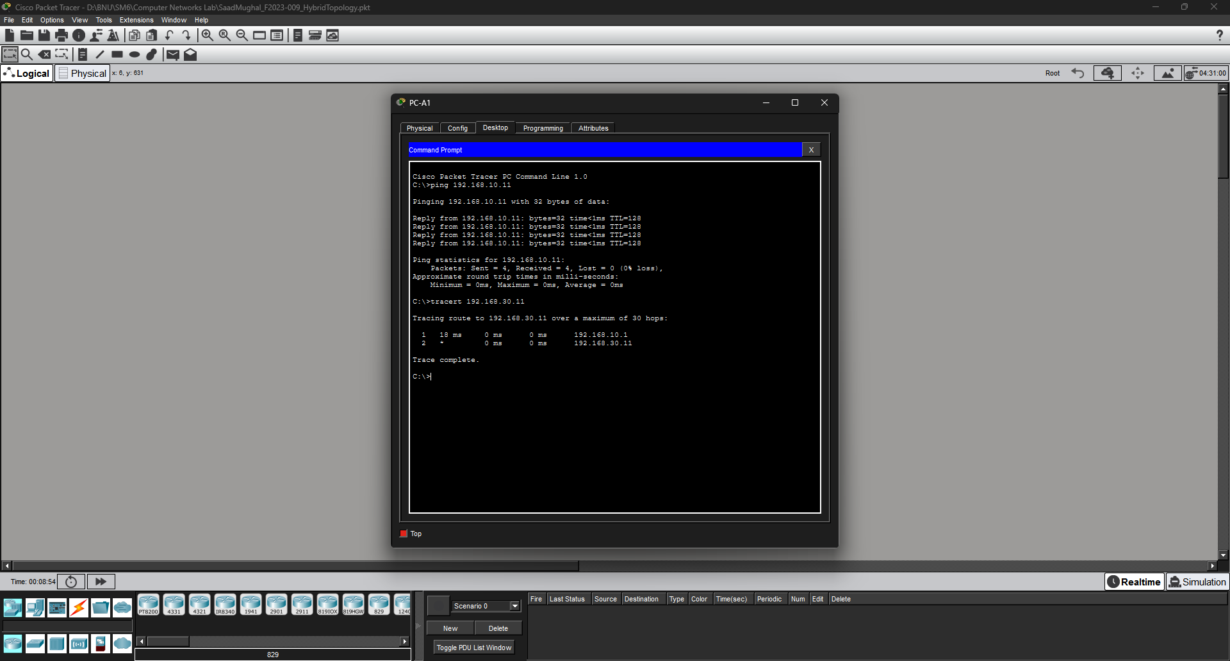

FROM PC-B1 TO PC-B2:
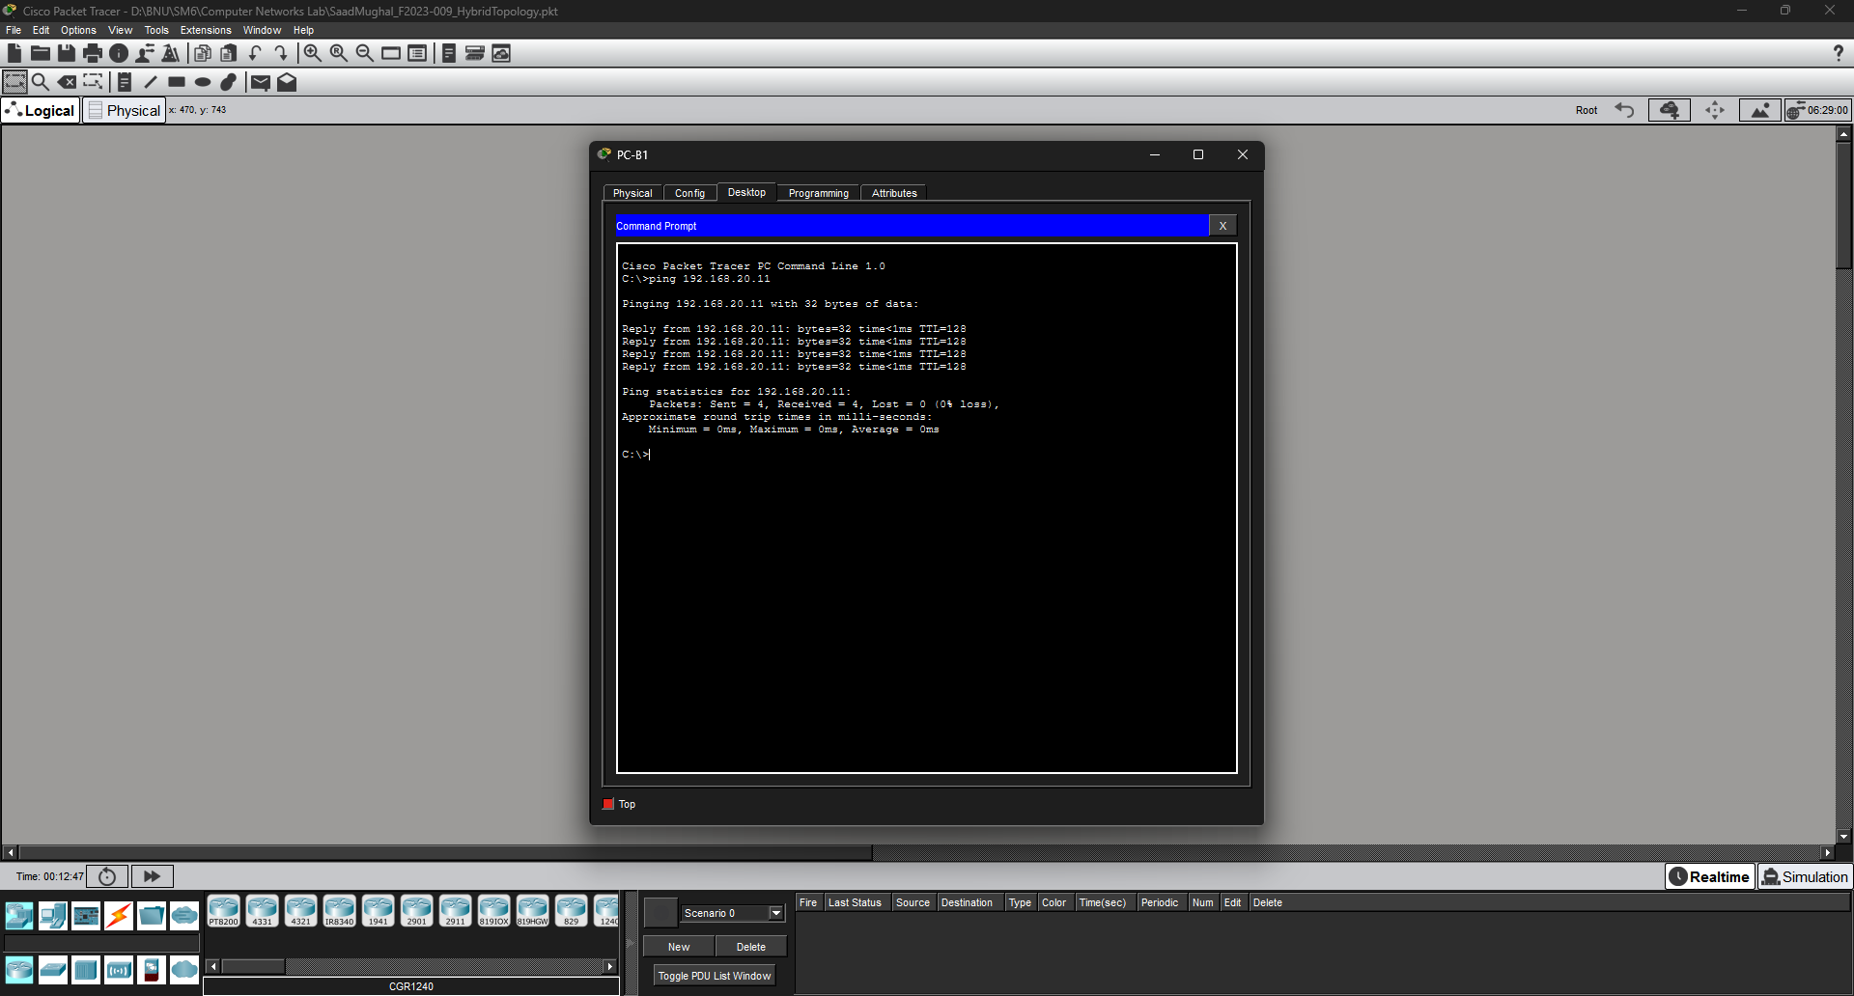

FROM PC-C1 TO PC-C2:
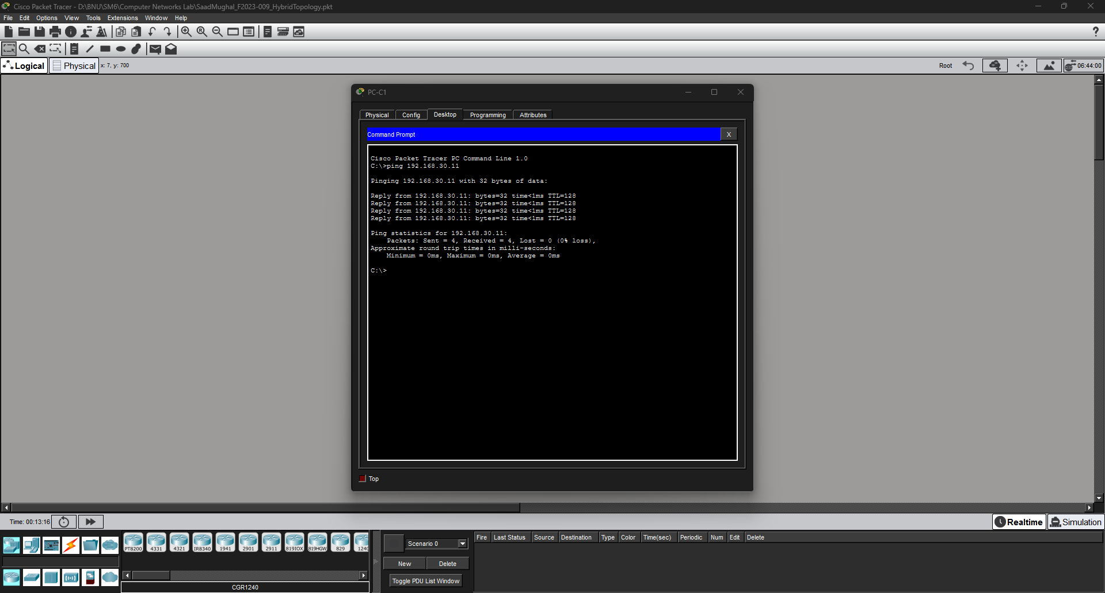

FROM PC-A1 TO PC-B1:
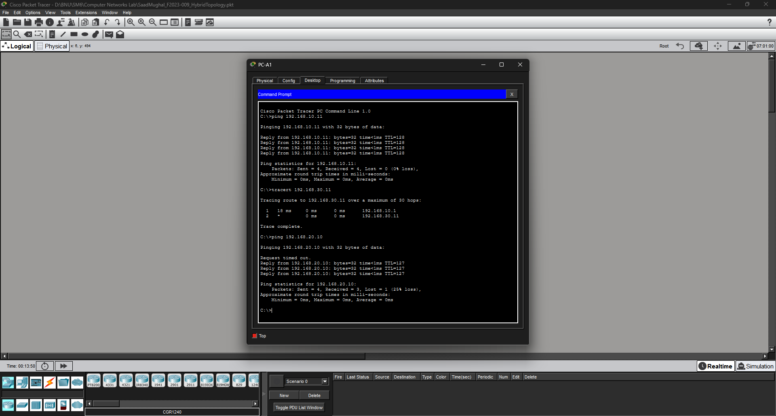

FROM PC-A1 TO PC-C1:
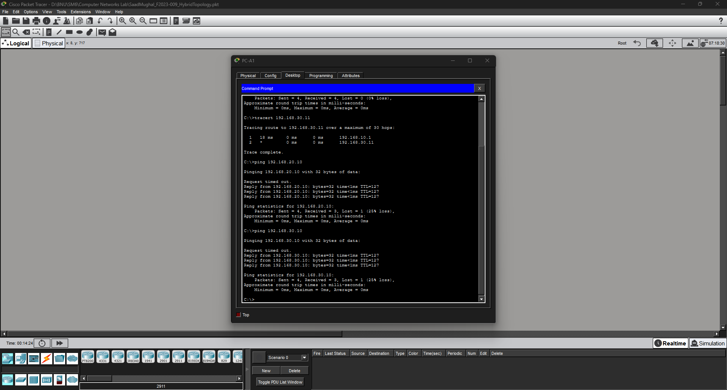

FROM PC-B2 TO PC-C2:
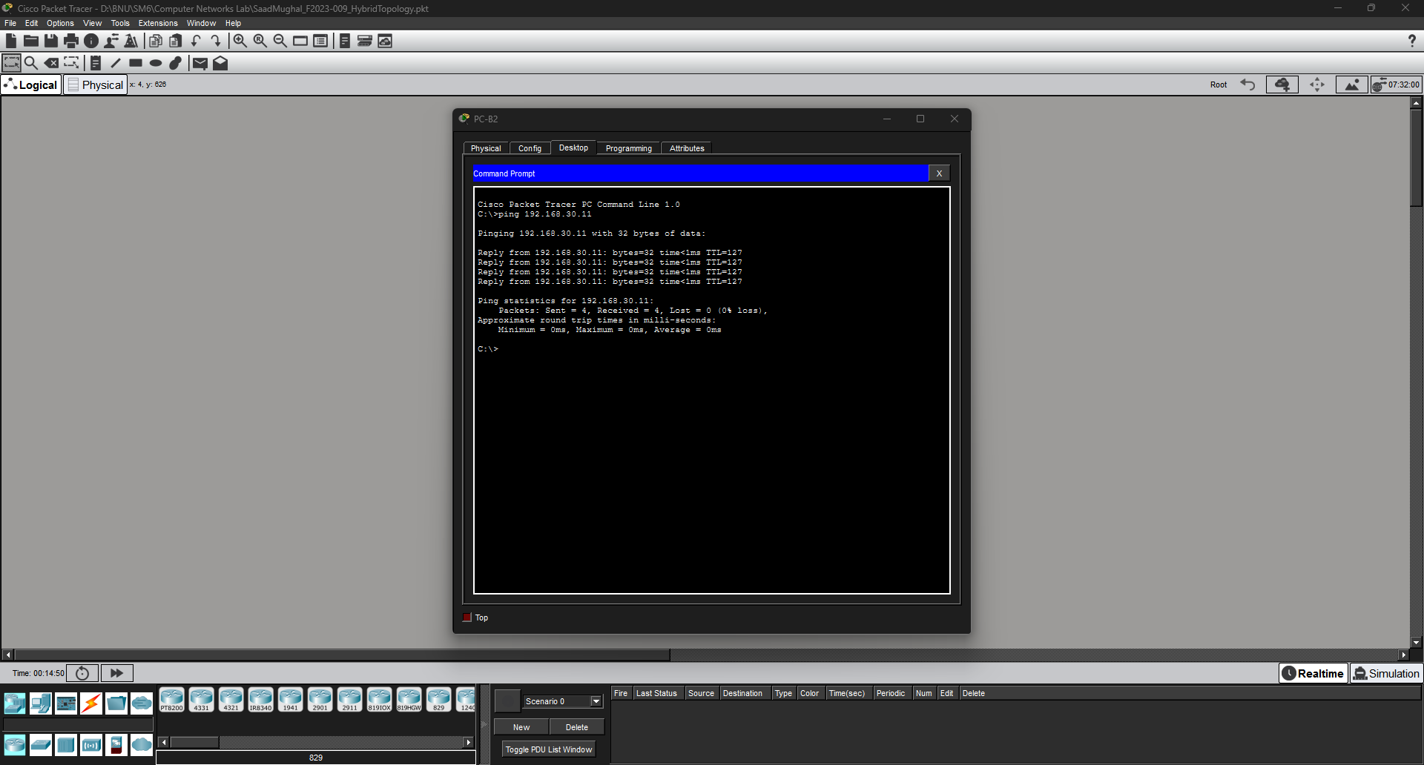

5. Deliverables & Submission
Submit the following items via the LMS before the deadline:

# | Deliverable | Details
1 | Packet Tracer File (.pkt) | Named: YourName_RollNo_HybridTopology.pkt
2 | Topology Screenshot | Full workspace showing all devices, all cables, with all link lights green.
3 | IP Configuration Screenshots | One screenshot per PC showing the static IP, subnet mask, and gateway entered.
4 | Ping Test Screenshots (×6) | One screenshot per ping test from the table in Step 6, showing the Command Prompt output.
5 | 'show ip interface brief' output | Screenshot from Router0 CLI showing all three interfaces as up/up.

⚠️ Note Submissions after the deadline will be penalised 50% per day. Identical .pkt files between students will be treated as plagiarism and result in an automatic F grade as per course policy.

6. Grading Rubric
Total: 20 Marks | CLO: CLO 4 — Configure network services in Cisco Packet Tracer [Bloom's Apply — C3]
Criterion | Marks | Full Marks  All criteria met | Partial  Minor errors | Needs Work  Major errors / missing
Topology Layout & Device Placement | 3 | All 10 devices placed and correctly labelled. Layout clearly shows hybrid structure (3 stars + 1 backbone router). | Devices placed but poorly labelled or arranged. 1–2 missing. (1–2 marks) | Topology incomplete or hybrid structure not visible. (0–1 mark)
Cable Connections | 1 | All 9 connections made with correct port selections. All link lights are green. | 1–2 wrong port selections or 1–2 orange links. (0.5 marks) | Multiple incorrect connections or broken links. (0 marks)
Router Interface Configuration | 3 | All 3 interfaces configured with correct IPs and 'no shutdown'. CLI output shows all up/up. | 1–2 interfaces correctly configured. One interface down or wrong IP. (1–2 marks) | Router not configured or all interfaces down/wrong. (0–1 mark)
PC Static IP Configuration | 2 | All 6 PCs have correct IP, subnet mask, and gateway. Screenshots submitted for each. | 4–5 PCs correctly configured. 1–2 have wrong gateway or IP. (1 mark(s)) | Fewer than 4 PCs configured or screenshots missing. (0 mark)
Ping Tests & Connectivity | 1 | All 6 ping tests pass (0% packet loss). Screenshots show successful replies for all. | 4–5 tests pass. Cross-segment pings attempted but 1–2 fail. (1 mark(s)) | Fewer than 4 tests pass or no screenshots provided. (0 mark)
TOTAL | 10 + 10 (the other 10 is based on an assignment quiz) = 20 Marks

7. CLO Mapping

CLO | Description | Tasks Covered | Bloom's Level | Marks
CLO 4 | Configure network services in Cisco Packet Tracer | Steps 1–6: Topology, Router Config, Static IPs, Ping Tests | Apply (C3) | 20 / 20

Build it, verify it, understand it — that is how engineers learn.
Instructor: Shazia Rizwan | Lab Instructor: Hasnain Ahmad | Spring 2026, BNU SCIT

